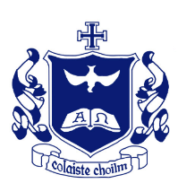
Coláiste Choilm Swords

A Blended Distance E-Learning Approach:
Responsibilities and Guidelines for the school community.

An Interim Policy
Reopening of school in January 2021
Table of Contents

Edmund Rice Education 2
The Edmund Rice Schools Trust Charter 3
Introduction 4
Scope of this Policy 4
Context 4
Responsibilities 5
Guidelines on the appropriate use of online Platforms for engaging in Remote Teaching and Learning: 6
Student Netiquette: 9
Appendix 1: Advice on teaching online 10
Appendix 2: Common questions on the use of Google Classroom 11

Edmund Rice Education

Congregation of Christian Brothers
The Congregation of Christian Brothers (Congregatio Fratrum Christianorum) is a worldwide religious community within the Catholic Church, founded by Blessed Edmund Rice in 1802. In 2008 the congregation was trustee of 96 schools in the Republic of Ireland.

Edmund Rice Schools Trust (ERST)
At the start of the new Millennium, the Christian Brothers founded by Blessed Edmund Rice decided to hand on responsibility for the schools to a group of lay people. The Edmund Rice Schools Trust (ERST) was established to hold the schools in trust so that they may continue to provide Catholic education into the future for the people of Ireland. Through reflection, and sharing, the school partners sought to reach consensus on what comprises the heart and soul of an Edmund Rice School. The educational approach of Blessed Edmund Rice schools is neither functional nor utilitarian, but subscribes to the holistic vision expressed in the following five key elements of the ERST Charter:
- Nurturing faith, Christian spirituality and Gospel-based values;
- Promoting partnership;
- Excelling in teaching and learning;
- Creating a caring school community;
- Inspiring transformational leadership

http://www.erst.ie/our-schools/the-erst-charter/
Mission Statement of Coláiste Choilm Swords
The aim of Coláiste Choilm is to provide a holistic education which is driven by a Catholic ethos.
We strive to create a safe environment which fosters inclusion, honesty, dignity and respect.
The school community encourages the individual in their pursuit of excellence.
We aim to promote among students a sense of pride in their school. The school is committed to:
- Respecting the dignity of the student with his background, tradition and beliefs, valuing the potential of each and encouraging the strong to support the weak;
- Enabling the student to develop a healthy self-image and to form positive relationships with others;
- Encouraging in the student a sense of creativity and of collaboration with others;
- Promoting the student’s appreciation of his cultural heritage;
- Preparing the student through academic and technical training for his vocational role in life;
- Providing opportunities for the student to experience God in the wonder of creation, in worship and in service of others.
- Developing a critical sense in the student, helping him to challenge the forces that threaten human life;
- Providing a disciplined atmosphere in which the student is encouraged to grow in freedom and to take increasing responsibility for his education and for the life of the school community.

http://colaistechoilmswords.ie/about-us/

The Edmund Rice Schools Trust Charter
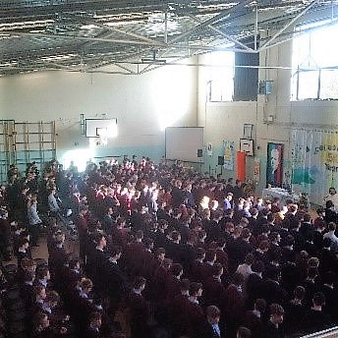
Nurturing faith, Christian spirituality and Gospel-based values
Edmund Rice Schools in partnership with the home and the parish are dedicated to providing and developing a Catholic education that cultivates a living faith, fosters Christian spirituality and educates people in Gospel based values.
Figure 1: The school community gathers for a celebration of the Eucharist in October 2017.

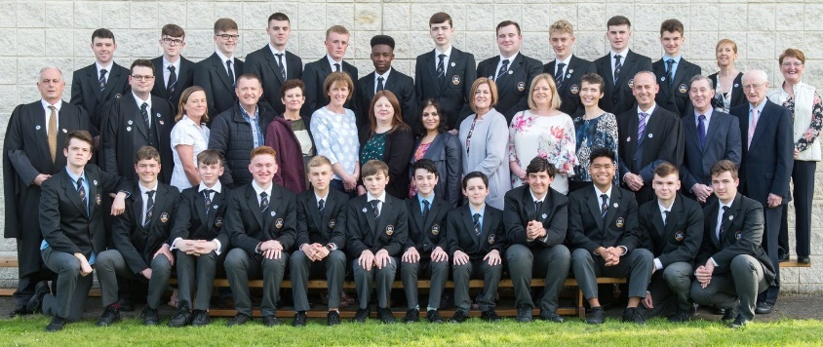
Promoting partnership
The Edmund Rice School is a welcoming community, where people are actively involved, their views are valued and their contribution is affirmed as they learn and grow together. Working together as partners improves the quality and effectiveness of the school. A spirit of partnership makes it easier to implement decisions and actions needed to achieve excellence.
Figure 2: ‘The Ceiliúradh Committee’ comprising of students, teachers, parents and management.
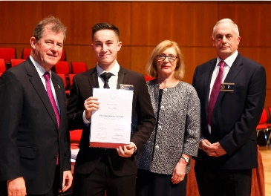
Excelling in teaching and learning
The Edmund Rice School is a community of people dedicated to the pursuit of excellence in all its endeavours and in all aspects of its teaching and learning.
Figure 3: Seán Mok (class of 2015) is presented with an All-Ireland Scholarship. Sean was congratulated by Mr. PJ McManus, Minister for Education and Skills, Ms Jan O’Sullivan T.D. and Mr David Neville (Principal)

Creating a caring school community
The hallmarks of an Edmund Rice school are care, especially for those who are vulnerable or disadvantaged in any way, and action for social and ecological justice.

Figure 4: Students in Coláiste Choilm
preparing for a hurling match.

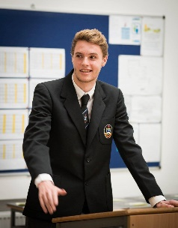
Inspiring transformational leadership
School leaders articulate a vision for their school in keeping with the Edmund Rice tradition. They inspire minds and hearts, raise critical consciousness and cultivate a strong work ethic coupled with an enterprising spirit.
Figure 5: Daniel Grace, Prefect 2017-18 addresses guests at the Golden Jubilee celebration

(Source: Edmund Rice Schools Trust Charter (2014) http://www.erst.ie/uploads/ERST-Charter_2014.pdf)

Introduction
This document sets out the policy of the school in respect of use of technology for distance or remote teaching and learning during the current Coronavirus stay at home instruction, hereafter referred to as “Distance eLearning” – it operates in addition to our existing Acceptable Use Policy (AUP).

Scope of this Policy
This policy covers any aspect of student distance learning as used by school staff.
In all cases students must use their @colaistechoilmswords.ie account to log in. Students are not to use any other account under any circumstances for the purposes of Distance eLearning.

This policy does not set out to replace our Mobile Phone Policy or Acceptable Usage Policy, but rather intends to be an important addition to the area of teaching and learning from a digital platform (i.e. remote teaching and learning).

The policy presented here should be read also in tandem with our school’s Code of Behaviour Policy and Anti-Bullying (including Cyber Bullying) Policy.

This Policy is prepared, therefore, in accordance with the provisions of the Department of Education and Skills and relevant sections of:
(a) The Education Act (1998)
(b) Education (Welfare) Act (2000)
(c) Equal Status Act (2000)
(d) Education for Persons with Special Educational Needs Act (2004)
(e) Disability Act (2005)
(f) Children First 2017
(g) GDPR
(h) Department of Education: Child Protection Procedures for Primary and Post Primary schools
(i) NEWB Guidelines for Developing a Code of Behaviour (2008).

Context
Teaching and Learning is always evolving, especially, as we move deeper into the 21st century. Developments in IT provide us all with great opportunities as learners and teachers. Never before has there been greater scope to learn using technology and it continues to change the learning relationship between teachers and students.

Advances in technology mean that assignments can be delivered remotely and that greater access to information on the internet affords the opportunities for real learning to take place under the watchful and professional guidance of the teacher.

However, whether a student is being directed remotely or via a traditional classroom environment, it is very important that all partners are aware that once a learning exchange takes place between a student and teacher, whether at home or at school, the same statutory rules apply i.e. the school’s Code of Behaviour and all of the school’s policies.

eLearning will take what is known as a blended approach and some teachers may use different methods more than another teacher. For example:
- Some teachers may use regular live classes while others may not
- Some teachers may distribute work as weekly bulk assignments while others may do so as daily homework-style tasks.
- In all cases the primary aim is to cover the required curriculum areas for their specific subject. The teacher will decide the most effective method to use to achieve this aim. Students should get in touch with their teacher right away if they are having difficulty with any aspect of their subject or if they are finding the workload unmanageable.

Responsibilities

For staff and teachers:

- Teachers have overall control of the online interaction of their class
- Disruptive students will be removed in order to allow those who wish to partake a fair chance to do so. Repeatedly disruptive students may receive a temporary ban from all online access.
- Teachers will do their utmost to be available at the identified time on their timetable – this may be via a Google meets video, or by e-mail.
- For students:
- You are to communicate through your @colaistechoilmswords.ie account only. The use of any other account or e-mail address is expressly prohibited
- Do not engage in communications with any account other than an @colaistechoilmswords.ie account.
- You must always be civil and respectful to your teachers and fellow students
- You are not to record or forward any content– such as worksheets, exam papers, answers, solutions, videos, notes or Google meet links – to anyone else without the permission of the creator of that content

For parents:

- You should ensure that your son is checking in regularly for assigned work
- Where live classes are being run you should ensure your son is in an area of the house that is quiet and free from distractions. Please be mindful of Child Protection Guidelines, for example, bedrooms should not be used for live classes
- Live online classes should be viewed by your son only.

Guidelines on the appropriate use of online Platforms for engaging in Remote Teaching and Learning:

- Teachers may deliver some of the course “live” using Google Meets. This will use varying combinations of audio, video, virtual whiteboards and screencasts.
- Students must always follow the direction of their teacher just as in the classroom
- Students are not to turn on their microphone unless the teacher invites them to do so. In any case, all microphones should be on mute when a person is not speaking to avoid distracting background noise being broadcast to everyone.
- Do not forward any link to anyone else.
- Check email, and google classroom regularly.
- Communication may only take place during normal school hours
- The normal school calendar will apply
- The school Code of Behaviour is applicable to remote teaching and learning including
  - Anti- Bullying Policy
  - Acceptable Use Policy
- Students with devices are reminded to use their school books, where possible, to complete assignments (as is the normal expectation)
- Teaching and Learning best practice will continue to apply with students expected to present all assignments to the best of their ability and on time, where this evolving and unprecedented situation allows you to do so.
- All staff and students have been given account details. If problems arise contact info@colaistechoilmswords.ie and the query will be resolved or referred to the relevant person.
- Teachers when working remotely will on most occasions try to communicate during normal working hours and will endeavour not to communicate with students outside of these hours. However, everyone’s circumstance is different, and we have to be as accommodating of all members of our school community as we can, especially in these uncertain times.
- Parents/guardians and students should note that teachers may have to send material/ assignments outside of regular school opening hours. This does not mean there is an expectation on the student to begin work at the time it is received.
- Likewise, there is never an expectation on the teacher to have to correct or comment on work sent via Google Classroom. Whilst it might suit teachers or students to communicate outside of normal working hours, it is essential that everyone agree that responses or actions outside of normal working hours are not required.

To support this, we urge all members of the school community to turn off notifications outside of their learning/working hours.
- The SEN department and SNA Team will endeavour to support all students with additional needs to access Remote Teaching and Learning. As far as possible, supported by the SNA Team provision for SEN students will be made when using Remote Learning methodologies.
- Recordings should not be made of any work by the student or anyone other person (e.g. video conference, live class, recorded video, PowerPoint with recorded explanations) unless with explicit permission from the teacher. In this instance, it is of utmost importance that any such recordings are not shared.
- Teachers may choose to conduct live classes through Google Meets. They may also use online educational platforms recommended by the PDST, for example Kahoot or Quizlet. We would like to avoid the scenario of students being compelled to disable their webcams and/or muting their audio. In order to avoid this scenario, we are using a high trust model. Teachers will trust students to behave appropriately online, as they would in their real classroom. Teachers & students’ clothing must be appropriate. Teachers and students should also be cognisant of the setting in which they conduct their live classes and be mindful of any personal belongings which may be visible on camera. Students will not record the class unless with the prior written permission (via Google Classroom/email) of the teacher conducting the live online class. If a recording is made with the permission of the teacher, it cannot be shared with anyone outside of the class. When using Google Meets or any other online interaction, students must at all times, use their own names and appropriate account pictures. If they do not adhere to this, they will be asked to take these down. If they do not follow instructions, or persist in continuing with this behaviour, they will be removed from the group or class, parents will be informed and sanctions applied as per the Code of Behaviour.
- Students may not record the live classes.
- A teacher will only correspond in and engage with a student who is signed up to a school agreed platform, Google Classroom using the @colaistechoilmswords.ie email
- Using social media sites (e.g. Facebook, Instagram, Twitter, Snapchat, Hangouts, WhatsApp etc.) to communicate with individual students is not encouraged and teachers have been advised accordingly. Social media may be used by teachers to demonstrate examples of good work to parents/guardians and the wider school community, but again is not encouraged for the conduct of teaching and learning. Any such activity will only be on the official school social media accounts (Facebook and Twitter). All student names on student work should be redacted.
- The material created by the teacher on Google Classroom is the property of the teacher and students do not have permission to share to others outside of the Google Classroom unless given permission to do so. Recordings should not be made of any online tutorial unless with explicit written permission (via google classroom/ email) from the teacher. In this instance, it is of utmost importance that any such recordings are not shared.

- As per all matters pertaining to our school’s Code of Behaviour, if a student acts in a fashion that is contrary to our Code’s expectations, they may receive a sanction as outlined in the Code of Behaviour
- Any behaviour or language deemed inappropriate during school applies online and after established school times. The consequences for such behaviour will be the same as if the student was in school, as they are involved in prescribed school work, on a school created platform using a school log-in and which has been directed by school personnel.
- The criteria for mandated Child Protection reporting remains the same as if the child was being taught in school.
- All provisions relating to the student’s data remains the same under GDPR procedures and guidelines.

- We recognise that teachers and students have a variety of circumstances that they are managing whilst engaging with remote teaching and learning. Acknowledging this, we understand that all students and teachers engage as best they can with all efforts at remote teaching and learning.
- No matter what time a student is on Google Classroom or Google Meets i.e. whether the teacher is online giving a tutorial or not - the moment a student logs onto these forums, they must abide by the school’s Code of Behaviour and the rules will be implemented if and when necessary according to this Code. Reporting structures for teachers remain the same as per Code of Behaviour.
- Students cannot choose to leave a Google Classroom once a teacher has created one. Students should notify the teacher/ask permission to leave should it be necessary to do so.
- In their communication with students, teachers should use a professional, considerate tone, being mindful of the fact there may be issues in the household regarding access to IT or possible Covid-19 related illnesses or concerns.
- It is expected that all students and teachers will engage as best they can with all efforts at online teaching and learning so as not to be behind when normal school resumes.

Student Netiquette:
- Our School’s Code of Behaviour, School Rules and our ICT Acceptable Use Policy apply to all Remote Learning.
- A high sense of respect is expected from students when engaging in Remote Learning.
- All students participating in online courses are expected to conduct their communications in a respectful manner.
- The use of proper Internet etiquette is expected at all times.
- Students are encouraged to interact with the platform provided but are asked use common sense in their interactions with one another and between student and teacher. Please do not add teachers to your personal Teams without their express permission.
- Circulating or publishing (including on the Internet) material recorded without consent with the purpose of humiliating, undermining the reputation of or causing damage to another person, whether considered a “joke” or not, may be considered as a serious breach of discipline. This could result in suspension or expulsion from school depending on the circumstances.
- Inappropriate language or behaviour will result in disciplinary action.
- Remember that Remote Learning is not private. Think about the consequences of anything you might write or post online.
- Above all, be positive in your engagement with Coláiste Choilm’s Blended Distance elearning approach.

We thank the school community for adhering to the above guidelines for everyone’s safety and welfare.
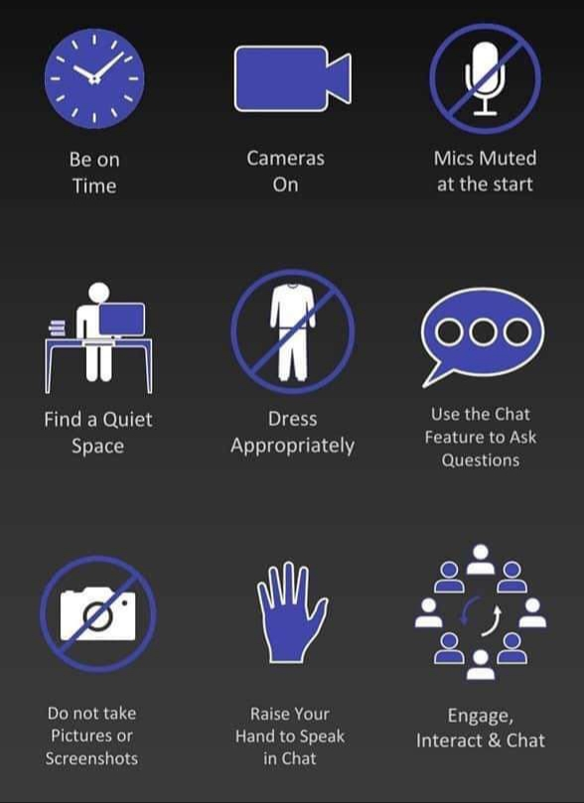

Appendix 1: Advice on teaching online
Start small and use an aspect of remote teaching that you are comfortable with.
• Remember to set your boundaries/classroom rules with the students. When they are on Google Classroom, they are in school.
• Give guidelines to students where you feel it necessary, around use of polite/professional language and appropriate times when communicating with you on Google Classroom.
• There is a ‘teacher only’ comments function in the settings to restrict students commenting/posting publicly which may also alleviate distraction to lessons.
• Should you feel anything said by a student is inappropriate or aggressive, please forward this to the relevant Year Head.
• Also, be mindful of your own wellbeing and if you are feeling overwhelmed with late emails or PMs, turn off the notifications on your phone/device at the end of the working day. A quick message to students on Google classroom often alleviates this issue.
• We advise all teachers to check all privacy settings on their own social media accounts and ensure that all accounts are set to private. If you are concerned about any unusual activity on said accounts, please forward it directly to the Senior Management team.
• Try as best you can to adhere to your timetable when delivering or uploading material to your Google Classes.
• Use the ‘schedule send’ option on Google Classroom or Gmail to upload messages or send emails to the students at the allocated class time for your subject on your timetable. This will help keep a routine in place for students.
• When uploading classwork, try to model the usual content that you would generally deliver in your 40 minute or double class. Too much work being uploaded at one time may overwhelm some students and too little won’t be challenging enough.
• Don’t try to reinvent the wheel – use your class notes that you have already prepared and upload that material. Also, there is a wide range of material available online which can be used linked to your chosen topic for your class.
• Remember to differentiate, as you would do naturally in your classroom. Remember the ‘few will be able to’, ‘some will be able to’ and ‘all will be able to’ approach to your questioning, homework and assignments.
• Use Success Criteria to aid you in monitoring student work/homework. Give formative feedback to the whole class group based on your success criteria and get the students to self-assess for daily evaluation of their knowledge/understanding. You can turn on the comments perhaps for this, and ask students to give a thumbs up/thumbs down to communicate their understanding.
• When marking student assignments, do this whatever way you are comfortable with. It could be through screen shots of their copies being uploaded, asking more senior students to type their answers (if they have access to an appropriate device) or perhaps the use of apps like quizlet or kahoot for more immediate marking. Again though, start small and do what is manageable for you.
• Communicate with the students around deadlines and when you expect to be back to them with marked assignments. Again, your feedback can be formative, summative or both. Uploading a sample answer is often a good idea to help students evaluate their own learning.
• If parents attempt to contact you through their son’s account, please forward this to the Senior Management team. The usual system of contact through the office email info@colaistechoilmswords.ie is what we recommend.
• Keep the lines of communication open with students. It is this consistency that will alleviate worries or anxiety. Students are really grateful for all your efforts to date.

Appendix 2: Common questions on the use of Google Classroom

As the weeks go on, there have been a number of ‘light bulb moments’ for us using Google Classroom in our online interactions with our students. We have all made great progress in making this step to online teaching and it has been a learning curve for everyone involved. From our conversations with you all over the past couple of weeks, there have been a few common questions coming up. So, we thought we would put together a few tips based on what has been asked.

• The first thing you must do is familiarise yourself with how to organise the online platform. You should try to post with purpose. The platform can get a little overwhelming if too much information is released in an unorganised way. Setting and really emphasising the due dates and deadlines will ensure student accountability. When uploading new files, organise them so that students can easily look and refer back to them.
• Avoid using the ‘stream’ option as your only means of communicating with students. Make full use of all options on the Google classroom platform.

In classwork, click the “+” button and choose from either ‘assignment’, ‘question’, ‘material’, ‘reuse post’ or ‘topic’ as a means of organising your google classroom page and your updates.
• In your stream you can ‘schedule send’ specific times for your notifications to upload. You really should schedule to send these notifications at the time you have the specific class on your timetable.
• I would encourage you to number your assignments in Google Classroom, so it is easy to instruct students to go to assignment number 2 now etc.
• Try recording audios or videos and attaching them as files to your assignments or classwork. Depending on students learning styles (audio or visual), they often appreciate the opportunity to hear your voice explaining the topic or assignment. This can also reduce the time it takes you to prepare your classes, as it is often a lot quicker to speak as you naturally would in your class, rather than typing your instructions/explanations! These recordings can be done in a number of different ways; through the use of ‘screen castify’ or even just using the microphone/camera feature on your laptop, phone or device.
• You can also attach links to online videos or resources that may be useful to support your lesson, assignment or classwork.
• There is a means of differentiating your assignments/questions to different groups of students as you naturally would in your class. You can do this by deselecting the ‘all students’ option on the right-hand side of your page, and then going in and selecting the relevant students.

• I like the ‘questions’ option which is now available in Google Classroom. It is a great way to get students to answer on a topic you have just taught. It is a good tool to use as an ‘exit pass’ at the end of the lesson.
• Give feedback with clarity to the students. When setting assignments, let the students know when to expect your feedback. This will ease anxiety around this.
• You can turn off student comments on your Google Classroom and there certainly is a place for this option. However, it is good practice to turn on the comments and encourage engagement, feedback and questions regularly and where appropriate.

Some teachers are keen to use a live platform in order to interact with their classes at times. We certainly encourage this type of interaction and there is a desire for it from students. We would ask that you use ‘Google Meets’ for this type of interaction. The reason for this is that we do not need to seek consent from parents as it is part of the GSuite system that we use in school. We have now enabled it in for your account. Please see the following tips that may help:
• To use Google Meets within your Google Classroom, simply go to the settings wheel in the top right side of your main page. Then scroll down to the ‘General’ section and you will see a google meets option. If you click on ‘generate meet link’, you will then create a link to an online interactive platform where you can teach some of your lessons. You have the option to turn on or off ‘visible to students’. This is a good way of easily creating an online platform to teach interactively at the times that suit you.
• When using Google Meets, make sure you are the first in the ‘Meets platform’ and last to leave. It is similar to having students in your physical classroom before or after you!

Finally, the following are some tips that I found online which may also help:
1. Use move to top to bring important older material back to students’ attention. This simple act bumps an assignment, announcement or question to the top of the class stream. Use this if students haven’t turned an assignment in OR if you want to remind them of an upcoming deadline.
2. Email everyone in a class in the “Students” tab. Once you click the “Students” tab, click the checkbox above all of your students to highlight everyone. Click “Actions” and “Email.” This is great for calling special attention to something you want to communicate to students OR for longer-form communication.
3. Adding class comments: Do this by adding a comment in your class stream on the “outside” of an assignment or announcement. This will make the comment visible to the entire class (important if it’s an answer to a question anyone might have).

4. Adding private comments: Do this by viewing student results and clicking on an individual student. On the right, where you can see student submissions, the comment bar at the bottom adds a comment that only the student can see (important if it has sensitive grade or feedback information).
5. Adding comments in a doc/slide/sheet/drawing: Do this by clicking on the student’s file that he/she submitted to you. Click the black speech bubble icon after highlighting something you’d like to comment on. This adds a very pointed comment on specific items in student work (important to be very exact in feedback).
6. Use announcements to share “right now” links. Announcements put content in your classroom stream without creating an assignment that students must turn in. Use them to give students important links, docs/files and videos they’ll need right now. (If it’s a resource they’ll need often, add that resource to the “About” tab instead.)
7. Use the keyboard instead of the mouse. Keyboard commands beat moving and clicking the mouse every time. The best one in Google Classroom: When entering grades, type the grade for a particular student’s assignment, then push the down key to get to the next student. Cycle through students with keystrokes instead of mouse clicks to save lots of time.
8. Reuse posts. Don’t recreate assignments, announcements or questions that are similar to those you’ve already created. Click the “+” button in the bottom right and select “reuse post.” Choose an assignment, announcement or question you’ve created before. You can modify and update it before you repost it.

