Coláiste Choilm launches its Golden Jubilee Year

On Monday, 4th September 1967, the first 26 students entered Coláiste Choilm Swords with, Br. Morgan Donnelly, C.F.C. (Headmaster) and the first teacher Mr. James Gibney,(RIP).

On Monday, 4th September 2017, 50 years to the day and date and the hour, Coláiste Choilm held its first annual Coláiste Choilm Day. It began when Br. Donnelly and Ms Maria Gibney Rodgers, (daughter of the late Mr. Gibney) and members of the first class, were joined with representatives of the Edmund Rice Schools Trust, Very Rev. Brother Edmund Garvey, C.F.C., Provincial of the Congregation of Christian Brothers (European Province) and members of the current and past Boards of Management and past Principals and teachers to ceremoniously walk across the entrance of our school and be received by a guard of honour of present day staff and students.

Following the procession guests enjoyed a ceremony and reception in the new Crannóg (ASD classroom). Speaking at the launch of the Golden Jubilee Year, Mr. David Neville (Principal) said it was very fitting that this ceremony takes place in the Crannóg classroom. “When the Christian Brothers founded Coláiste Choilm CBS in 1967, they did so to provide free education to boys who otherwise would have had no school to attend. Today we celebrate our school becoming 50 years of age, in a classroom suite built for the same purpose. Half a century later the mission of Edmund Rice Education is a living force in Coláiste Choilm.”

In 1967 on the day Coláiste Choilm opened, the students and staff were addressed by the Very Reverend Brother Creed, C.F.C., the Brother Provincial. In 2017, 50 years to the day and date, Coláiste Choilm was honoured to welcome the Very Reverend Brother Edmund Garvey, C.F.C., Provincial of the Congregation of Christian Brothers (European Province). Br. Garvey opened proceedings by leading guests in a prayer for Mr. Seamus Greene, first lay Principal of Coláiste Choilm who recently passed away. Br Garvey wished Coláiste Choilm every success in the next fifty years. “I wish the whole school well within the Edmund Rice Schools Trust. I urge you to value the gift of education. There is no doubt in my mind that we are facing a new kind of world – a world more and more characterised as one in which ‘God makes all things new’, as it says in the scriptures. We need a new kind of education for this new and emerging world.”

Ms. Patricia McCrossan, Chair of the Board of Directors and Mr. Pat Keating, attended on behalf of the Edmund Rice Schools Trust. Mr. Pat Keating congratulated the school on reaching this important milestone. Mr. Alfred Bryan, Chair of the Board of Management of Coláiste Choilm addressed invited guests and reminded them of the simple beginnings of the school when the teaching staff came into school on the summer holidays to paint the building. Mr. Noel Murray – Hession Trustee Representative on the Board of Management and former Chair of the Parents Council, also wished the school well for the next 50 years and remembered the fundraising efforts of parents to raise over IR£300,000 to ensure the school was built.

Mr. Cathal Boyle (Deputy Principal) highlighted the motto of Coláiste Choilm "mol an oige agus tiocfaidh si". (Praise the young and they will blossom.) “50 years ago the Christian brothers were asked to open a school in Swords and the seed that was Colaiste Choilm was firmly planted. The seed has grown and is an integral part of the community educating young men in the Edmund Rice tradition. This ethos and set of values has spread across the globe as illustrated by Professor Colm Kearney, Dean of Monash Business School, a member of the first class in Colaiste Choilm responding from Australia.”

Mr. Kevin Reidy (class of ’67) spoke of his days in Coláiste Choilm with Br. Donnelly and Mr. Gibney with great affection. Mr. Michael Dunne (class of ’67) read a poem he wrote as a first year student. Daniel Grace, 6th year student and a Cinnire (Prefect) was the final speaker. A presentation was then made to each of the original class, Christian Brothers and ERST. Mr. Karl Foster, (Co-ordinating Teacher), closed the event by leading the assembled guests in a prayer which he wrote specially for Coláiste Choilm.

After a reception, guests joined the full school community on the pitch for an aerial photograph marking the 50th anniversary of Coláiste Choilm. School photographs were taken and the day finished with a reception for the Leaving Certificate Class of 2017 who were welcomed back for the occasion.

Coláiste Choilm by Michael Dunne, First Year Class of 1967-68
I started school on 4th September,
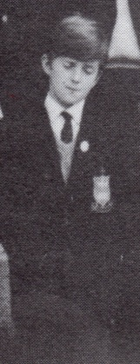
That is a day I will always remember,
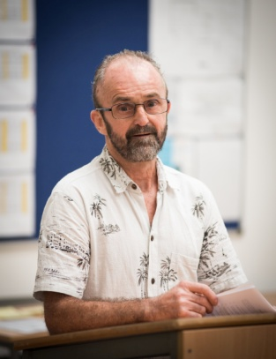
Coláiste Choilm is its name and
I hope it brings fortune and fame.

Brother Donnelly is the Head and
All things must be done as he said,
Mr Gibney is his right hand man,
And he does his best,
Whenever he can.
Michael Dunne,
reading the poem he wrote as a First Year student in Coláiste Choilm 50 years ago.
Michael Dunne,
First Year,
Coláiste Choilm 1967

The Prayer of Coláiste Choilm

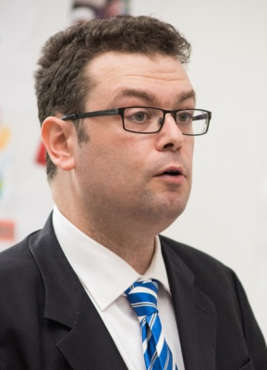
O Everlasting God, we beseech you to continue to shine your light on Coláiste Choilm as you have done in past generations.

Grant to the future generations you have called to labour here, to learn and to teach, the way of your enlightenment of your eternal knowledge.

Help us to continue on your path of learning and service as illuminated by your servant, Blessed Edmund Ignatius Rice.
Amen.
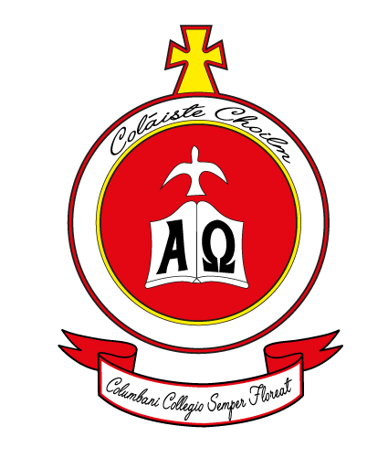
Past Pupils Union
In April 2017, in preparation for the Golden Jubilee Year, Mr. Cathal Boyle (Deputy Principal) and Mr. Karl Foster (Teacher) launched the Past Pupils Union of Colaiste Choilm on Facebook which contains all the photographs from our school’s history. It is followed by almost 700 past pupils and staff.

The crest of the Past Pupils Union was designed by Andrew Crowley (6th year) and features a Latin phrase written by Br. Donnelly, (first Headmaster)
Columbani Collegio semper floreat
(Coláiste Choilm grow forever)

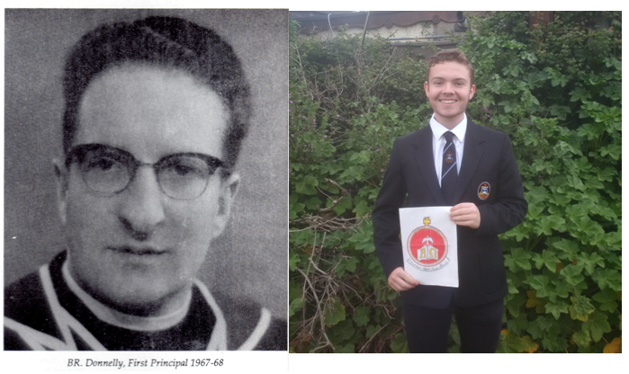

Cinnire (Prefect)

The leadership shown by the Chistian Brothers in establishing Coláiste Choilm was celebrated on Blessed Edmund Rice Day, 5th May 2017 when Coláiste Choilm launched the new role of Prefect for 6th year students. Prefects are our school’s role models. Prefects make a valuable contribution to the wider school community at Coláiste Choilm, taking on important leadership roles, assisting and supporting both staff and pupils, liaising with prospective parents and pupils and other visitors. The prefect ‎is also called the Cinnire (guide). By their appearance, manner, attitude, relationships and deeds will act as a guide to younger students and their peers to the standards expected.

School Crest: (In gold for the golden jubilee)
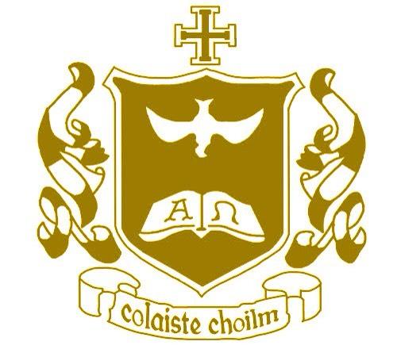
Screen Shot of Photographs Attached via Dropbox link
